Introduction
This technical note describes how to setup the ReceiptNow to print graphic headers, footers and watermarks. Once the ReceiptNow printer driver has been installed, no special utility is required to setup the printer for printing headers, footers and watermarks. These operations can be controlled through the standard Windows ‘Printer&Faxes’.

For headers and footers there are two distinct and separate operations to be performed. The first step is to download graphic images to the printer which stores these graphics internal to the printer. These images remain in the printer after the unit has been powered off. After downloading the graphics, the printer can be moved from one computer to another, and the graphics can be used for printing from the new computer. This allows the printer to have the graphics downloaded to the printer in one location that is not necessarily the same location where the final printing is to be performed

The bitmap images must be one bit per pixel monochrome and no wider than 600 pixels (assuming 3 inch wide paper is used) and no taller than 760 pixels.

Multiple bitmaps images can be downloaded to the device. The total size of all images must not exceed 1.5Mb.

The second operation for headers and footers which also applies to watermarks is performed on the computer that is connected to the printer and will control the printer during print operations. This operation is used to define which graphic image is to be used for a header, footer or watermark.

These steps are all controlled from Windows ‘Printer&Faxes’.

Downloading Graphic Image to the ReceiptNOW printer
To download graphic images to the printer complete the following steps:

Open the printers dialog box from the start menu

Start->All Programs-> Printers and Faxes -> SRN 2PTR(U) 1
Right click on ‘SRN 2PTR(U) 1’ and select ‘Properties’.

Click on the Download tab
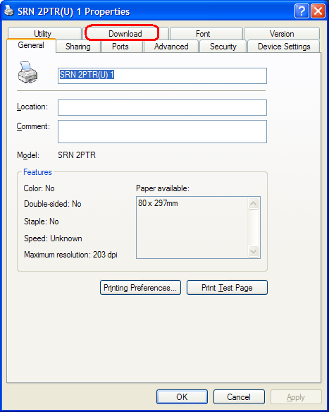

Click ‘Add’
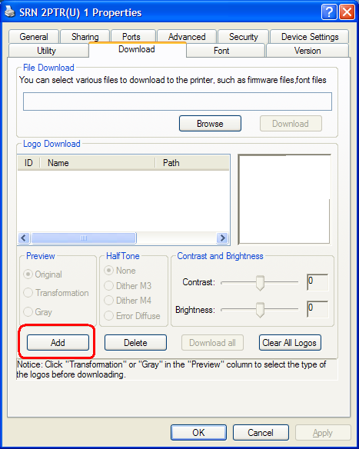
Using the dialog box, navigate to the folder that contains the desired logo bitmap file and click ‘Open’
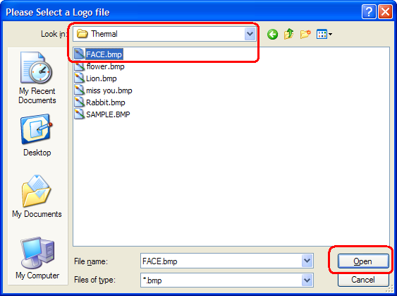

Repeat this process to download other bitmap files as desired.
For each file in the list of graphic images that have been downloaded, click ‘Transformation’ as shown below, then click ‘Download All’. Make note of the ‘ID’ number that is listed with the bitmap file. The ID number will be used in the steps for selecting which graphic is used for a header or footer.
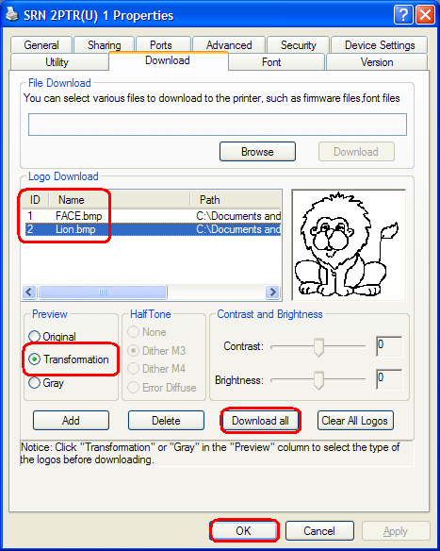

This completes the steps required for downloading a graphic image file that gets stored in the printer. The next step is to associate a particular bitmap with various printer operations.

Setting up the ReceiptNOW printer to print a header or a footer
The following sets of steps are performed on the computer that is to be performing the printing. As mentioned earlier, this does not need to be the same computer that was used for downloading graphic images to the printer. First start Windows ‘Printer&Faxes’

Start->All Programs-> Printers and Faxes -> SRN 2PTR(U) 1
Right click on ‘SRN 2PTR(U) 1’ and select ‘Properties’.

Click on the ‘General’ tab and then select ‘Printing Preferences’
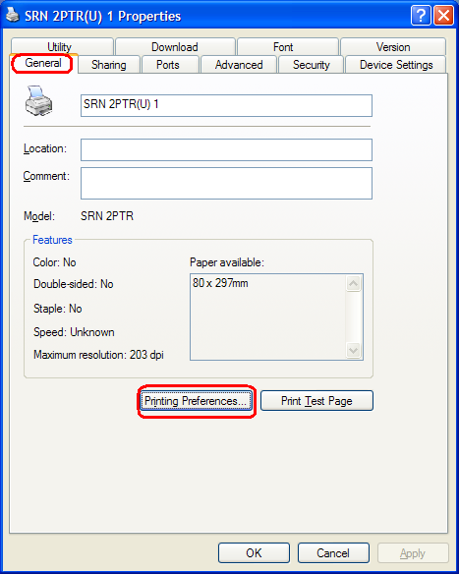
Select ‘Operation’. Graphic images can be setup to print at the start of a document, start of each page, end of each page or the end of the document. Select the appropriate action that is required.
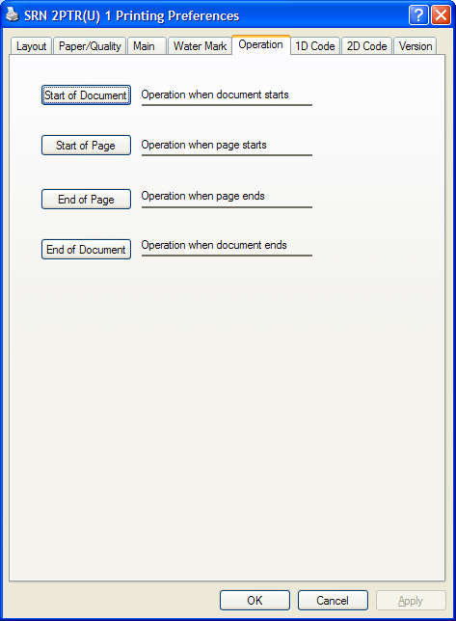
Select the desired logo to print using the ID number of the downloaded bitmap file. The logo can be justified left or right or centered on the paper. The logo can also be positioned to occur either before or after the cut. After setting up, click ‘OK’ and then click ‘OK’ again to close out of the Windows ‘Printer&Faxes’.

Print jobs sent to this Windows printer will then be printed with the selected bitmaps printed at the locations that were specified. This completes the setup for selecting graphic logos to be used as a header or footer to a document.

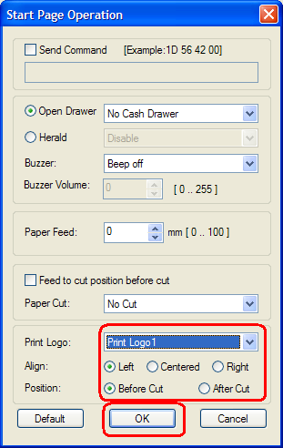

Setting up the ReceiptNOW printer to print a watermark
The following sets of steps are performed on the computer that is to be performing the printing. As mentioned earlier, this does not need to be the same computer that was used for downloading graphic images to the printer. First start Windows ‘Printer&Faxes’

Start->All Programs-> Printers and Faxes -> SRN 2PTR(U) 1
Right click on ‘SRN 2PTR(U) 1’ and select ‘Properties’.

Click on the ‘General’ tab and then select ‘Printing Preferences’
Next click on the ‘Watermark’ tab. This tab allows for a bitmap image file to be used as a watermark or a text string to be used as a watermark. Select the desired watermark type, adjust the print position as required and then press ‘Apply’. If there are no other printer settings that need to be changed, then click ‘OK’ to close out the printer properties dialog.

Print jobs sent to this Windows printer will then be printed with the watermark printed on every page. This completes the setup for adding watermarks to printed documents.

