SmartPVA 9.3.6 Build 6 Demo Tool Instructions

You can download SmartPVA_9.3.6_Build_6_NoInstall.zip from the link below and unzip the content to a folder of choice.
https://digitalcheck.sharefile.com/d-s5ce764894154c788

Next, go to the folder and double click the SmartSourceDemo.bat file to launch the Demo tool.
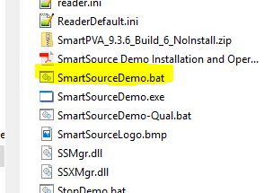

When the Device options box pops up, select the “Expert / Elite” radio button and enter the “Sorter Identifier” (IP Address of scanner) and the “IP Address Base”(IP Address of local Network Controller).

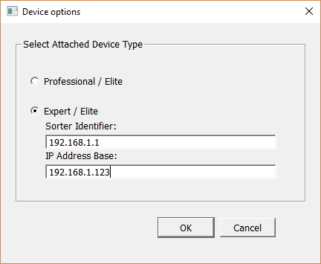

Press the Start scan button to begin scanning documents.
